UOC 5 MODULE 02- INFORMATION SHEET
Module Title: Web Server, Domain, Hosting & Local Development Environment
Duration: 6 Hours
Theory: 2 Hours
Practical: 4 Hours

1. Learning Objectives
After completing this module, the learner will be able to:
- Explain the concept of a web server.
- Describe how a website is delivered to users.
- Explain domain names and DNS.
- Explain web hosting and different types of hosting.
- Differentiate between domain and hosting.
- Explain HTTP and HTTPS.
- Set up a local development environment.
- Access localhost.
- Create a database using phpMyAdmin.
- Perform basic database operations.

2. Introduction
Before developing a dynamic website using a CMS such as WordPress, it is important to understand the basic infrastructure required to run a website.
A typical website requires:
Domain Name (By Registration)
+
Web Hosting / Web Server
+
CMS/Application
+
Database
+
Website Files

3. What is a Domain Name?
A domain name is the human-readable address used to access a website on the Internet.

Examples
google.com
wordpress.org
example.com
Instead of remembering a numerical IP address, users can use a domain name.

Example
Domain Name:
www.example.com

IP Address:
203.0.113.10
The actual IP address will vary; the example above is for illustration.

4. Parts of a Domain Name
Consider:
www.example.com
Part | Meaning
www | Subdomain/host name commonly used for web services
example | Domain name
.com | Top-level domain (TLD)

Common TLDs
- .com – Commercial/general use
- .org – Organizations
- .net – Network-related/general use
- .edu – Educational institutions in certain contexts
- .gov – Government entities in certain contexts
- .bd – Bangladesh country-code domain

5. What is DNS?
DNS stands for Domain Name System.
DNS translates domain names into IP addresses so that computers can locate the appropriate server.

Example
User enters:
www.example.com
↓
DNS
↓
IP address of the server
↓
Web Server
↓
Website

Simple Definition
DNS is the system that helps convert human-readable domain names into IP addresses.

Domain Registration

What is Domain Registration?
Domain registration is the process of purchasing and registering a unique domain name for a website through a domain registrar.
A domain name is the address that people type into a web browser to visit a website.

Example
- google.com
- facebook.com
- anzmlabs.com
When you register a domain name, you obtain the right to use that domain for a specific period, usually one year or more.

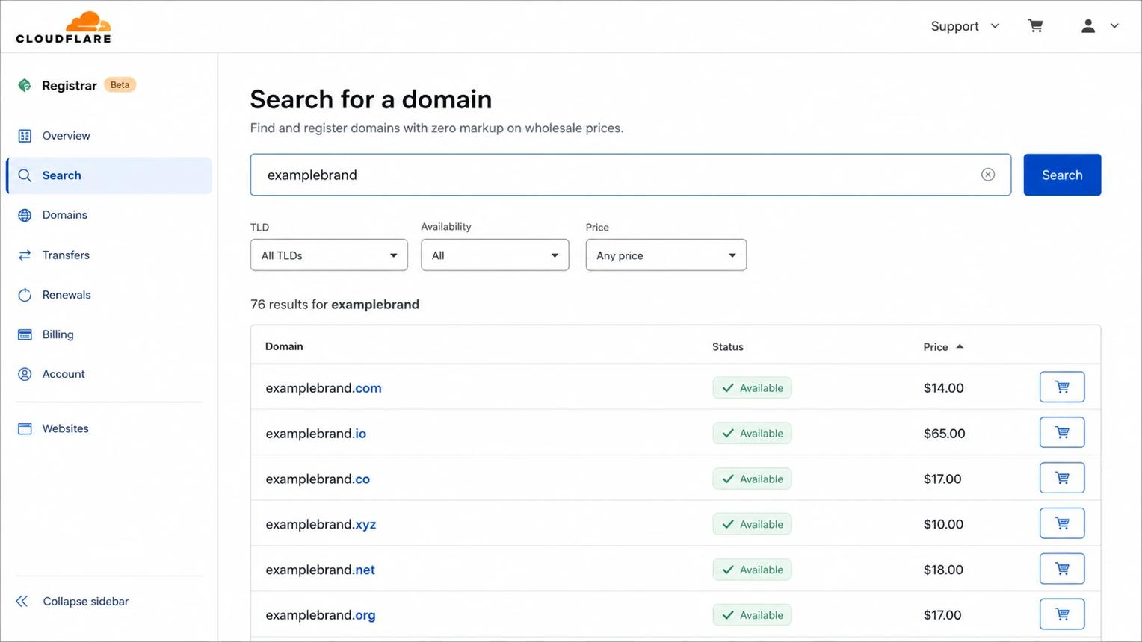
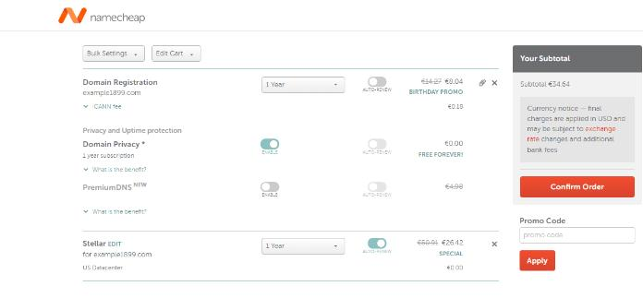
5

How Domain Registration Works
- Search for a domain name
Choose a name, such as mywebsite.com.
Check whether the name is available.
- Select and purchase
Choose a registrar and pay the registration fee.
The registrar submits the registration.
- Use the domain
Connect it to hosting and publish your website.

Important Terms
|
Term
|
Meaning
|
| --- | --- |
|
Domain Name
|
The address of a website.
|
|
Domain Registrar
|
A company that registers domain names.
|
|
TLD
|
The extension of a domain, such as .com, .org, or .net.
|
|
Registration Fee
|
The amount paid to register a domain.
|
|
Renewal
|
Extending the registration after it expires.
|
|
DNS
|
The system that connects a domain name to a server's IP address.
|

Domain Name Structure
In example.com, "example" is the domain label and ".com" is the top-level domain.

Examples of Domain Extensions
- .com — Commercial websites.
- .org — Organizations.
- .net — Network-related websites.
- .edu — Educational institutions (subject to registration rules).
- .bd — Bangladesh country-code domain.

Domain Registration vs Web Hosting
|
Domain Registration
|
Web Hosting
|
| --- | --- |
|
Provides the website address.
|
Stores website files on a server.
|
|
Example: mywebsite.com
|
Stores HTML, CSS, JavaScript, images, etc.
|
|
Registered through a registrar.
|
Purchased from a hosting provider.
|
Simple example: A domain is like the address of a house, while web hosting is like the land and building where the website lives.

Steps to Register a Domain
- Choose a unique domain name.
- Check domain availability.
- Select a domain registrar.
- Create an account.
- Pay the registration fee.
- Complete the registration process.
- Configure DNS and connect the domain to web hosting.

Popular Domain Registrars

Namecheap
Domain registration and hosting services.
Official website

GoDaddy
Domain names, hosting, and website services.
Official website

Cloudflare
Domain registration and DNS services.
Official website

Short Answer for Students
Domain registration is the process of registering a unique website address, such as example.com, through a domain registrar for a specific period.

How Does a Domain Registrar Work with a Hosting Server to Access a Website?
A domain registrar and a hosting server work together to make a website accessible through the internet.
Let's understand with a simple example.
Suppose you create a website:
www.mywebsite.com
You want people to type this address in their browser and see your website.

1. The Three Main Parts

- Domain Registrar
A company where you register your domain name.
Example: mywebsite.com

- Hosting Server
A server that stores your website files.
Example: HTML, CSS, JavaScript, images, and WordPress files.

- Web Browser
The browser sends a request to the website and displays the response.
Examples: Chrome, Edge, Firefox.

2. How They Work Together
Here is the complete process:
Diagram options

Step-by-step explanation
Step 1

Register a domain
You register mywebsite.com through a domain registrar.
The registrar records your domain registration and lets you manage its DNS settings.
Step 2

Purchase web hosting
You buy hosting from a hosting provider.
Your website files are uploaded to a server. The server has an IP address, for example:
203.0.113.10
This is an example IP address.
Step 3

Connect domain to hosting
You configure DNS so that mywebsite.com points to your hosting server.
Example DNS record:
Type
A
Name
@
Value
203.0.113.10
The A record connects the domain to an IPv4 address. The IP above is illustrative.
Step 4

User visits the website
The user types:
https://mywebsite.com
The browser needs to find the server's IP address.
Step 5

DNS finds the server
The browser uses DNS to translate:
mywebsite.com → 203.0.113.10
DNS is like the internet's phonebook: it finds the IP address associated with a domain name.
Step 6

Hosting server sends the website
The browser connects to the hosting server and requests the webpage.
The server sends back the HTML, CSS, JavaScript, and other required files.
Step 7

Website displays in the browser
The browser receives the files and renders the website on the user's screen.

3. Important: Who Does What?
|
Component
|
Main responsibility
|
| --- | --- |
|
Domain Registrar
|
Registers your domain and provides domain management.
|
|
DNS
|
Translates the domain name into a server IP address.
|
|
Hosting Server
|
Stores and delivers your website files.
|
|
Web Browser
|
Requests and displays the website.
|
The domain registrar does not normally store your website files. The hosting server does that.

4. Real-Life Example
Imagine you register:
anzmlabs.com
You purchase hosting from a hosting provider.
Your setup might look like this:

anzmlabs.com
Your registered domain
DNS points to hosting

Hosting Server
Website files and server software
index.html
style.css
script.js
HTTP / HTTPS response
Website appears in the browser

5. What Happens If You Only Register a Domain?
If you register a domain but do not purchase hosting:
- The domain name exists.
- You can manage its DNS.
- There may be no website to display.
For example, you register mywebsite.com but have no hosting server. When someone visits the domain, they may see a parking page, an error, or another configured destination.

6. What Happens If You Only Buy Hosting?
If you purchase hosting but do not register a domain:
- Your website files can still be stored on the hosting server.
- You may access the website using a temporary hosting URL or IP address, depending on the provider.
- Visitors cannot use your desired custom domain until it is registered and connected.

Remember This Simple Formula

Domain + DNS + Hosting = Website Access
Domain gives the address → DNS finds the server → Hosting delivers the website.
Important: A domain registrar, DNS service, and hosting provider can be different companies. Some hosting providers also offer domain registration and DNS management in the same account.

Why Does a Hosting Company Provide Two IP Addresses?
When you purchase web hosting, especially shared hosting, the hosting company may provide two Name Server (NS) addresses.
These are usually provided to connect your domain name with your hosting server.

1. Example of Two Name Servers
Suppose you purchase hosting from a company. They give you:
Nameserver 1:
ns1.examplehost.com

Nameserver 2:
ns2.examplehost.com
These are called two nameservers, not necessarily two IP addresses.
You may also see their IP addresses:
ns1.examplehost.com → 192.0.2.10
ns2.examplehost.com → 192.0.2.11
The IP addresses above are examples.

2. How Two Nameservers Connect Your Domain to Hosting

Your Domain
mywebsite.com
You update nameservers at your registrar

Hosting Nameservers
ns1.examplehost.com
Primary DNS
ns2.examplehost.com
Secondary DNS
DNS resolves your domain

Hosting Server
Your website files
Website delivered
Website opens in the browser

3. Why Do They Provide Two?
The main reason is redundancy and reliability.
|
Nameserver
|
Purpose
|
| --- | --- |
|
NS1
|
Primary DNS server that answers domain lookup requests.
|
|
NS2
|
Secondary DNS server that can answer if the primary is unavailable.
|
If one DNS server has a problem, another may still respond.
Two nameservers do not necessarily mean your website is stored on two different hosting servers. They are DNS services, and both may point to the same hosting infrastructure.

4. Where Do You Enter These Two Nameservers?
You enter them at the company where you registered your domain.
For example, if you registered your domain at Namecheap and purchased hosting from another company:
Domain Registrar
Where your domain is registered.
Change Nameservers
Nameserver 1
ns1.examplehost.com
Nameserver 2
ns2.examplehost.com
DNS points to your hosting
Hosting Server
Your website becomes accessible.

5. What Is the Difference Between IP Address and Nameserver?
This is important because hosting companies may provide either two nameservers or two IP addresses.
|
Nameservers
|
IP Addresses
|
| --- | --- |
|
Example: ns1.examplehost.com
|
Example: 203.0.113.10
|
|
Used to manage DNS for your domain.
|
Identifies a server on the network.
|
|
Usually entered in the domain's nameserver settings.
|
Used in DNS records such as A records.
|

Example A record
Type: A
Name: @
Value: 203.0.113.10
This connects your domain to the hosting server's IPv4 address.

Example nameserver settings
Nameserver 1: ns1.examplehost.com
Nameserver 2: ns2.examplehost.com
This tells your domain to use the hosting company's DNS servers.

Short Answer for Students
A hosting company commonly provides two nameservers so that your domain can use the hosting company's DNS service. The nameservers help translate your domain name into the IP address of the hosting server, allowing visitors to access your website.
One question: Did your hosting company give you two addresses like:
- ns1.something.com and ns2.something.com — these are nameservers.
Or like:
- 123.456.78.90 and 123.456.78.91 — these are IP addresses.
If you share the two addresses (you can hide the company name), I can explain exactly what they do.

6. What is Web Hosting?
Web hosting is a service that provides server resources where website files, databases and applications can be stored and made accessible over the Internet.
When a website is hosted on a server, visitors can access it through its domain name or another assigned address.

7. Domain vs Web Hosting
These two terms are often confused.
Domain | Hosting
Website address | Server space/resources
Used to locate a website | Used to store/run website
Example: example.com | Server where website files are hosted
Similar to an address | Similar to the place/building

Simple Example
Think of a website as a house:
Domain = Address of the house
Hosting = House/building
Website = Contents inside the house

8. Types of Web Hosting

8.1 Shared Hosting
Several websites share resources on one server.

Advantages
- Low cost
- Easy to manage
- Suitable for beginners

Disadvantages
- Resources are shared
- Performance can be affected by other accounts
- Less control than advanced hosting

8.2 VPS Hosting
VPS stands for Virtual Private Server.
A physical server is divided into virtual environments with allocated resources.

Advantages
- More control
- Better resource isolation than typical shared hosting
- Suitable for growing websites

Disadvantages
- More expensive
- Requires more technical knowledge, especially for unmanaged VPS

8.3 Dedicated Server
A dedicated server provides a physical server primarily for one customer.

Advantages
- High control
- Dedicated resources
- Suitable for demanding workloads

Disadvantages
- More expensive
- Requires administration and maintenance

8.4 Cloud Hosting
Cloud hosting uses infrastructure distributed across multiple servers or resources.

Advantages
- Scalable
- Flexible
- Can provide high availability depending on architecture

Disadvantages
- Pricing can be more complex
- Configuration can require technical knowledge

9. What is HTTP?
HTTP stands for Hypertext Transfer Protocol.
It is a protocol used for communication between web clients and servers.
Example:
http://example.com
When a browser requests a webpage, HTTP is one of the protocols used to transfer the request and response.

10. What is HTTPS?
HTTPS stands for Hypertext Transfer Protocol Secure.
HTTPS uses encryption through TLS (Transport Layer Security) to protect data exchanged between the browser and server.
Example:
https://example.com

Benefits of HTTPS
- Encrypts data in transit
- Helps protect login credentials
- Helps protect sensitive information during transmission
- Provides website authentication through certificates
- Required or strongly recommended for many modern web applications

HTTP vs HTTPS
HTTP | HTTPS
Not encrypted by TLS | Encrypted using TLS
Less secure for sensitive data | More secure for data transmission
Uses http:// | Uses https://
Modern websites generally prefer HTTPS | Recommended for modern websites

11. WordPress Database
WordPress stores much of its structured information in a database.
Examples include:
- Posts
- Pages
- Users
- Comments
- Categories
- Tags
- Settings
A simplified representation is:
WordPress
│
├── Website Files
│
└── Database
│
├── Posts
├── Pages
├── Users
├── Comments
└── Settings

12. Local Development Environment
A local development environment allows developers to build and test a website on their own computer before publishing it to the Internet.

Advantages
- No hosting required during development
- Can work without Internet after software is installed
- Safe environment for testing
- Faster experimentation
- Useful for learning WordPress
- Website can be developed before deployment

Example
Your Computer
│
├── Web Server
├── PHP
├── Database
└── WordPress

13. XAMPP
XAMPP is a local development package commonly used to run PHP-based applications.
The name is commonly explained as:
- X – Cross-platform
- A – Apache
- M – MariaDB/MySQL
- P – PHP
- P – Perl
For a WordPress learning environment, the important components are generally Apache, PHP and MariaDB/MySQL.

Localhost refers to the computer currently being used.
A common localhost address is:
http://localhost/
When Apache is running in XAMPP, for example, the browser can access websites hosted on the local computer.

Example
http://localhost/
or, depending on the setup:
http://localhost/mywebsite/

26. Practical Activity 1: Install XAMPP

Objective
To create a local web development environment.

Procedure
Step 1: Download XAMPP from the official Apache Friends website.
Step 2: Install XAMPP.
Step 3: Open the XAMPP Control Panel.
Step 4: Start:
Apache
MySQL
Step 5: Open a browser.
Step 6: Enter:
http://localhost/

Expected Result
The XAMPP/local server page should open.

27. Practical Activity 2: Create a Database Using phpMyAdmin

Objective
To create a database for a WordPress website.

Procedure
Step 1: Start Apache and MySQL.
Step 2: Open:
http://localhost/phpmyadmin/
Step 3: Select Databases.
Step 4: Enter a database name, for example:
training_institute
Step 5: Create the database.

Expected Result
A new database named:
training_institute
should appear in phpMyAdmin.

28. Practical Activity 3: Explore phpMyAdmin
Learners should identify:
- Databases
- Tables
- Structure
- SQL
- Search
- Insert
- Export
- Import

Important Precaution
Do not delete or modify an important database without permission and a backup.

29. Practical Activity 4: Create a Local Website Folder
For a typical XAMPP installation, website files can be placed under:
C:\xampp\htdocs\
Create:
C:\xampp\htdocs\training
Then a browser may access it through:
http://localhost/training/
The exact location can differ if XAMPP was installed in another directory.

30. Practical Activity 5: Test PHP
Create a file named:
test.php
with:
<?php
echo "PHP is working!";
?>
Place it inside the website folder.
For example:
C:\xampp\htdocs\training\test.php
Then open:
http://localhost/training/test.php

Expected Result
The browser should display:
PHP is working!

31. Practical Activity 6: Prepare Environment for WordPress
Before installing WordPress, confirm:

Server
- Apache is running
- Database server is running
- PHP is available
- Browser can access localhost

Database
- Database has been created
- Database name is recorded
- Database credentials are known

WordPress
- WordPress package is available
- WordPress files are extracted
- Files are placed in the appropriate web directory

32. Basic Website Infrastructure
A complete online WordPress website can be represented as:
DOMAIN
│
▼
DNS
│
▼
WEB HOSTING
│
┌───────┴────────┐
▼ ▼
WEB SERVER DATABASE
│ │
└───────┬────────┘
▼
WORDPRESS
│
▼
WEBSITE CONTENT
│
▼
USER

33. Important Terminology
Term | Meaning
Web Server | System/software that serves web resources
Apache | Popular web server software
Nginx | Web server/reverse proxy
Domain | Human-readable website address
DNS | System that maps domain names to IP addresses
Hosting | Service/infrastructure for running a website online
HTTP | Web communication protocol
HTTPS | HTTP secured using TLS
Database | Organized collection of data
MySQL | Relational database management system
MariaDB | Open-source relational database system
PHP | Server-side programming language
Localhost | The local computer
XAMPP | Local PHP/web development package
LocalWP | WordPress-focused local development tool
phpMyAdmin | Web interface for managing MySQL/MariaDB

34. Review Questions

Short Questions
- What is a web server?
- What is Apache?
- What is Nginx?
- What is a domain name?
- What is DNS?
- What is web hosting?
- What is the difference between a domain and hosting?
- What is HTTP?
- What is HTTPS?
- What is a database?
- What is MySQL?
- What is MariaDB?
- What is localhost?
- What is XAMPP?
- What is LocalWP?
- What is phpMyAdmin?
- What is the purpose of Apache in XAMPP?
- What is the purpose of MySQL/MariaDB in XAMPP?
- Why is a database required by WordPress?
- What is a local development environment?

35. Practical Exercises

Exercise 1
Install XAMPP and verify that Apache and MySQL can run.

Exercise 2
Open:
http://localhost/
and verify that the local web server is working.

Exercise 3
Open:
http://localhost/phpmyadmin/
and create a database named:
cms_training

Exercise 4
Create a folder:
C:\xampp\htdocs\cms_training

Exercise 5
Create and run a simple PHP file.

Exercise 6
Draw the following infrastructure:
Domain → DNS → Hosting → Web Server → WordPress → Database
and explain each component.

36. Knowledge Check

Fill in the Blanks
- CMS websites commonly use a __________ to store structured data.
- __________ is a popular web server software.
- __________ translates domain names into IP addresses.
- __________ is the local computer address commonly used for testing websites.
- XAMPP commonly includes Apache, MariaDB/MySQL, PHP and __________.
- __________ is a web-based tool for managing MySQL/MariaDB databases.
- HTTPS uses __________ to protect data in transit.
- PHP is a __________-side programming language.

Answers
- Database
- Apache
- DNS
- localhost
- Perl
- phpMyAdmin
- TLS
- server

37. Module 02 Practical Assignment

Assignment Title
Set Up a Local Development Environment for WordPress

Scenario
A training institute wants to develop its website using WordPress. Before publishing the website online, you must prepare a local development environment.

Tasks
- Install XAMPP or LocalWP.
- Start the required services.
- Test localhost.
- Create a database.
- Open phpMyAdmin.
- Create a website directory.
- Test PHP.
- Download/extract WordPress.
- Prepare the environment for WordPress installation.
- Document the steps with screenshots.

Expected Output
The learner should submit:
- Screenshot of the local server/control panel
- Screenshot of localhost
- Screenshot of phpMyAdmin
- Screenshot of created database
- Screenshot of website directory
- Screenshot of successful PHP test
- A short written procedure

38. Module 02 Assessment
Assessment Area | Marks
Web server concepts | 5
Domain, DNS and hosting | 5
HTTP/HTTPS | 5
Database concepts | 5
XAMPP/LocalWP setup | 10
Database creation | 5
PHP/localhost test | 5
Total | 40

Practical Competency Checklist
- Explains web server
- Explains domain
- Explains DNS
- Explains web hosting
- Differentiates domain and hosting
- Explains HTTP and HTTPS
- Explains database
- Explains MySQL/MariaDB
- Installs/configures local environment
- Starts Apache
- Starts MySQL/MariaDB
- Opens localhost
- Opens phpMyAdmin
- Creates a database
- Tests PHP successfully
- Prepares environment for WordPress installation
End of Information Sheet – Module 02

